Date: 17/11/2024
Roll No. and Name: 24ITC087 Khush Pithva
Course Code and Name: 2CS101 Computer Programming

Practical No: 9(a)
Aim: Write a UDF using the concept of pointers which can accept a one dimensional array as an argument. The function should add 1 to all odd elements of the array and 2 to all even elements of the array. The final array should be displayed by the main() function. Repeat this program for a two dimensional array.

Methodology Followed:

#include<stdio.h>
void m2DArray(int *arr, int n, int m)
{
for (int i = 0; i < n; i++)
{
for (int j = 0; j < m; j++)
{
int *ptr = arr + (i * m) + j;

if (*ptr % 2 == 0)
{
*ptr += 2;
} else
{
*ptr += 1;
}
}
}
}
void m1DArray(int *arr, int size) {
for (int i = 0; i < size; i++) {
if (*(arr + i) % 2 == 0) {
*(arr + i) += 2;
} else {
*(arr + i) += 1;
}
}
}
int main()
{

int choice;
printf("press 1 for 1D array.\n");
printf("press 2 for 2D array.\n");
scanf("%d",&choice);
if(choice == 1)
{
int n;
printf("Enter the size of the array: ");
scanf("%d", &n);

int arr[n];
printf("Enter %d elements:\n", n);
for (int i = 0; i < n; i++) {
scanf("%d", &arr[i]);
}

m1DArray(arr, n);

printf("Modified array:\n");
for (int i = 0; i < n; i++) {
printf("%d ", arr[i]);
}
printf("\n");
}
if(choice ==2)
{
int n, m;

printf("Enter the number of rows: ");
scanf("%d", &n);
printf("Enter the number of columns: ");
scanf("%d", &m);

int arr[n][m];
printf("Enter the elements of the array (%d x %d):\n", n, m);
for (int i = 0; i < n; i++) {
for (int j = 0; j < m; j++) {
scanf("%d", &arr[i][j]);
}
}

m2DArray((int *)arr, n, m);

printf("Modified 2D array:\n");
for (int i = 0; i < n; i++) {
for (int j = 0; j < m; j++) {
printf("%d ", arr[i][j]);
}
printf("\n");
}
}
}
Input/Output:
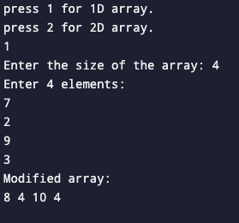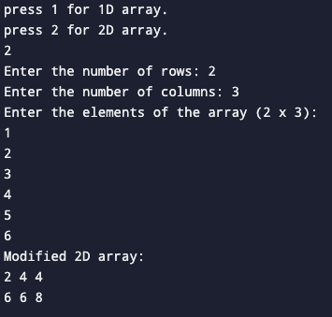

Theoretical Principle:Used the concept of pointer and array together to perform airthemetics operations on the elements of the array.

Practical No:9(b)
Aim:Write a program to print array elements in reverse using a pointer.
Methodology Followed:
#include<stdio.h>

int main()
{
int n;
int *ptr;

printf("Enter the number of elements in the array: ");
scanf("%d", &n);

int array[n];
ptr = array;

printf("Enter %d elements: \n", n);
for(int i = 0; i < n; i++)
{
scanf("%d", ptr);
ptr++;
}

printf("Reversed array is: ");
ptr--;

for(int i = n; i > 0; i--)
{
printf("%d ", *ptr);
ptr--;
}

printf("\n");
return 0;
}

Input/Output:
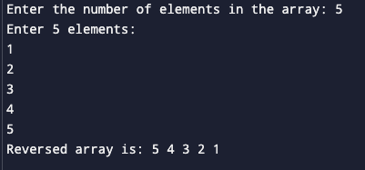

Theoretical Principle: Used pointers to print the array elements in the reverse order.

Practical No: 9(c)
Aim: Write a UDF which accepts three strings as arguments. The function should concatenate the first two strings and keep the result in the third string which should be displayed by the main() function.
Methodology Followed:
#include<stdio.h>
#include<string.h>

void concatenate (char s1[], char s2[],char result[])
{
while (*s1 != '\0') {
*result = *s1;
s1++;
result++;
}

while (*s2 != '\0') {
*result = *s2;
s2++;
result++;
}
*result = '\0';

}
int main()
{
char s1[100], s2[100], result[200];
printf("Enter first string : ");
gets(s1);
printf("Enter second string : ");
gets(s2);
concatenate(s1,s2,result);
printf("concatenate string is : %s",result);
return 0;

}
Input/Output:
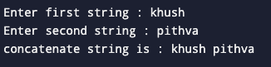

Theoretical Principle: Make a user defined function to concatenate strings using a pointer.
Conclusion: Multiple concepts of C language like functions, arrays, strings and pointers are used together.

